25.48: a)
This is less than the previous value of 24 W.
b) The work dissipated in the battery is just: 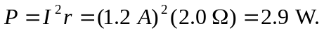 This is less than 8 W, the amount found in Example (25.9).
c) The net power output of the battery is 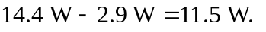This is less than 16 W, the amount found in Example (25.9).

